Tephra Glass Trace Element Database
Student: Logan Lumley Kerr (3135694)
Supervisor: Serhiy Buryak
Department: EASC
Institution: MacEwan University
Date: 9/26/2025

1. Introduction
Ash fallout (tephra) is used with uranium-lead dating of zircon crystals to approximate the timing of sedimentary deposition in cases where no discrete volcanic ash beds are present. Being able to identify ages of specific tephra layers allows geologists to map the distance from their volcanic source, estimate the geographic extent of fallout, and refine the timing of related tephra deposits. These age constraints also provide valuable chronological control for reconstructing regional tectonic events, climatic changes, and biological records preserved within associated sediments. In this way, tephra not only serves as a marker horizon within stratigraphy but also as a tool for linking local sedimentary sequences to broader volcanic and environmental histories.
The Grubstake tephra is a ~12 m thick rhyolitic ash bed in the Alaska Range, dated at 6.83 ± 0.11 Ma by 40Ar/39Ar methods. Geochemical evidence links it to Aleutian Arc volcanism during the late Miocene, a period of significant tectonic and geomorphic change in the region. It lies within the Grubstake Formation, the uppermost unit of the Usibelli Group, which consists mainly of lacustrine deposits interbedded with volcanic horizons. The overlying Nenana Gravel records nearly 1200 m of foreland basin sedimentation, interpreted as a response to rapid unroofing of the Alaska Range beginning around this time.
Taking readings from tephra can create mountains of unorganized data and unintelligible data to people who aren’t specialized in the field. . To address this issue we would need to create a better way of storing data that can (i) Create a user-friendly graphical user interface (GUI) for ease of use (ii) Load faster with a greater amount of data (iii) Keep it organized and easily shareable with others around the world (iv) Be able to convert past semi-organized data into the newer format for easier integration.

2. Literature Review
Zircon geochronology, specifically U-Pb dating of volcanic zircon has become a widely used method of dating sedimentary basins. Early studies (e.g., Gebauer et al. 1989; Bitshene and Schmincke, 1990) demonstrated the value of zircons in sedimentary layering where other dating tools would have been unavailable. More recent work has applied this approach to reconstruct tectonic and erosional history within Alaska and the Yukon as well as paleoclimate changes tied to tephra and the correlations of widespread volcanic horizons across continents. These studies highlight the versatility of zircon dating around the world.
Despite these advances significant gaps remain. Most detrital zircon studies rely on sand sized grains yet volcanogenic zircons are often finer and are easily lost in mineral separation. This leads to an under representation of syn-depositional zircons in sedimentary records. Adhered volcanic glass coatings can be destroyed during preparation, making identification of eruption based zircons yield few to none recognizable volcanic zircons.
The mismatch between known volcanic activity and the absence of syn-depositional zircon signals highlights in the need for better recovery techniques as well as better data handling as a lot of data is either unreadable or unorganized and thus lost.

3. Methods
Currently this research project would be focused on handling data and preserving it properly in a way that is easy to read and more efficient to store by cutting load times. The data that will be used for testing how well the developed software will work will be Grubstake Tephra data as it will be newly collected and will show the strengths of the program in development. The program will allow for storing the data in database files rather that excel spreadsheets which will cut load times and search times for the data itself. Since this will be using SQL it would be appropriate to allow users to also use their own SQL queries so they can find exactly what they are looking for, this would require some technical knowledge but is completely optional for the average user.
The program should also include a way to convert older datasets into this new format as to allow for an easy transition into using the software. Development will mainly consist of python programming and using tkinter to design a proper graphical user interface. Backend of the program as iterated previously will be using SQL which allows for data to be stored and appended to easily using either the software itself or manual editing through SQL queries. Careful documentation will be made within the code itself as to ensure others in the field with expertise in coding could add to the software if they deem willing to do so. Features from other software will either be implemented right away or over time depending on usage and need for certain tools but designing the software in a way that allows for modularity will allow for easier implementation of entire new tools.

4. Outcomes
I hope that the program that is developed can be robust and more visually appealing than other limited options as well as being more user friendly for beginners going into the field. The biggest implication of having this program could be wide adoption of its usage making the entire environment of storing data better for the users so they can focus more on collecting data rather than figuring out how niche programs work.

5. References
Benowitz, J.A., Layer, P.W., & Vanlaningham, S. (2014). Persistent long-term (c. 24 Ma) exhumation in the Eastern Alaska Range constrained by stacked thermochronology. Geological Society, London, Special Publications, 378, 225–243. https://doi.org/10.1144/SP378.12
Bitschene, P.R., & Schmincke, H.-U. (1990). Fallout tephra layers: Composition and significance. In D. Heling, P. Rothe, U. Förstner, & P. Stoffers (Eds.), Sediments and Environmental Geochemistry: Selected Aspects and Case Histories (pp. 48–82). Springer. https://doi.org/10.1007/978-3-642-75097-7_4
Brennan, P.R.K., & Ridgway, K.D. (2015). Detrital zircon record of Neogene exhumation of the central Alaska Range: A far-field upper plate response to flat-slab subduction. GSA Bulletin, 127, 945–961. https://doi.org/10.1130/B31164.1
Buryak, S.D., Reyes, A.V., Jensen, B.J.L., Davies, J.H.F.L., Westgate, J.A., DuFrane, S.A., Luo, Y., Froese, D.G., Pearson, D.G., & Benowitz, J.A. (2022). Laser-ablation ICP-MS zircon U-Pb ages for key Pliocene–Pleistocene tephra beds in unglaciated Yukon and Alaska. Quaternary Geochronology, 68, 101398. https://doi.org/10.1016/j.quageo.2022.101398
Enkelmann, E., Sanchez Lohff, S.K., & Finzel, E.S. (2019). Detrital zircon double-dating of forearc basin strata reveals magmatic, exhumational, and thermal history of sediment source areas. GSA Bulletin, 131, 1364–1384. https://doi.org/10.1130/B35043.1
Gebauer, D., Williams, I.S., Compston, W., & Grünenfelder, M. (1989). The development of the Central European continental crust since the Early Archaean based on conventional and ion-microprobe dating of up to 3.84 b.y. old detrital zircons. Tectonophysics, 157, 81–96. https://doi.org/10.1016/0040-1951(89)90342-9

6. Figures
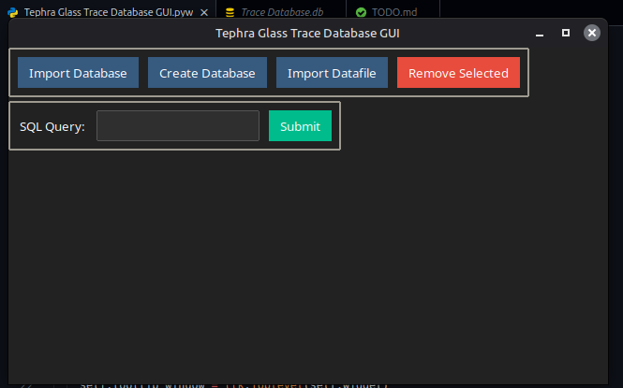
Figure 1. Early stages of software development

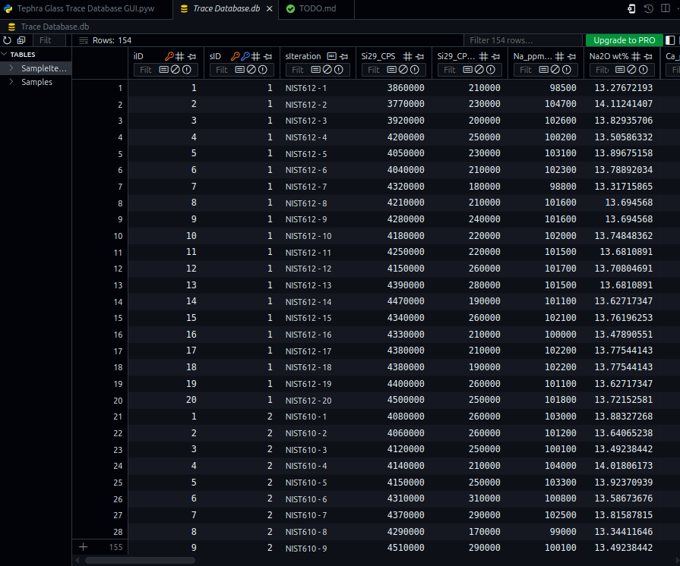
Figure 2. Current design of backend database
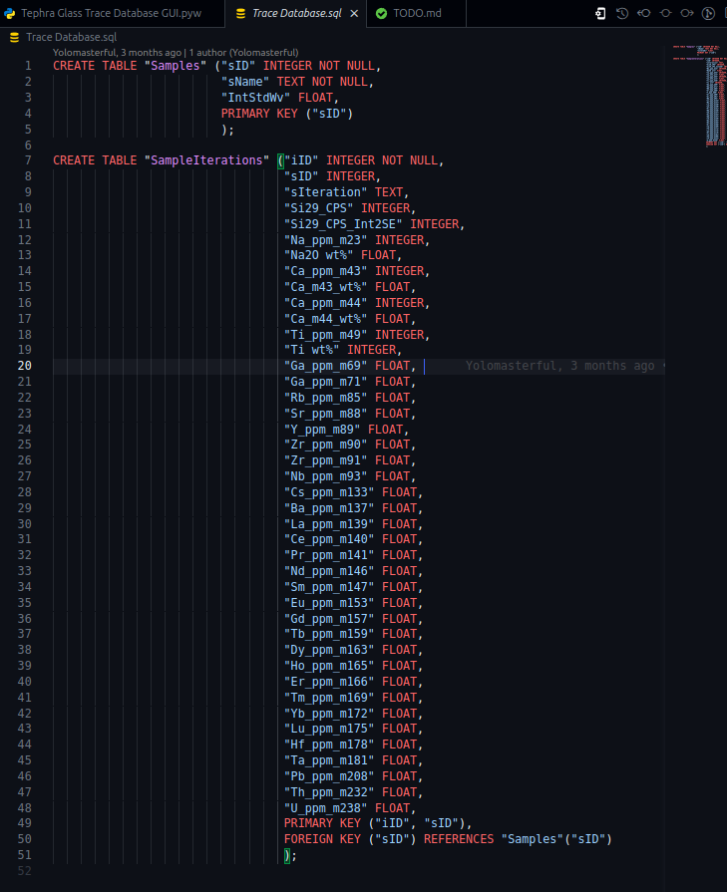
Figure 3. Database SQL schema

